Mindomo Tutorial
Basic info
Let me give you more information about Mindomo.
At first, let`s open the link in Google. After the opening, you are supposed to see the Log in button on the right top corner, just click it.
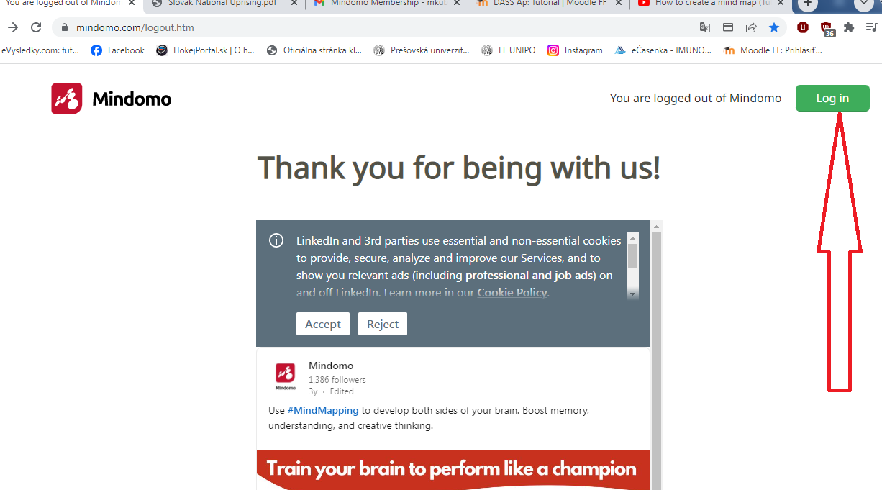

After clicking, it is recquired to enter your email and password to log in.
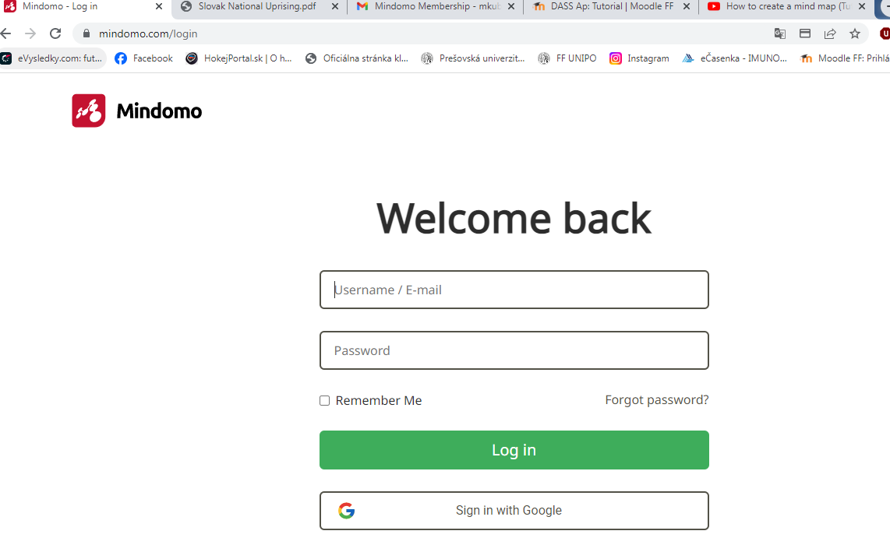

When you enter the platform,you wil see the following screen.
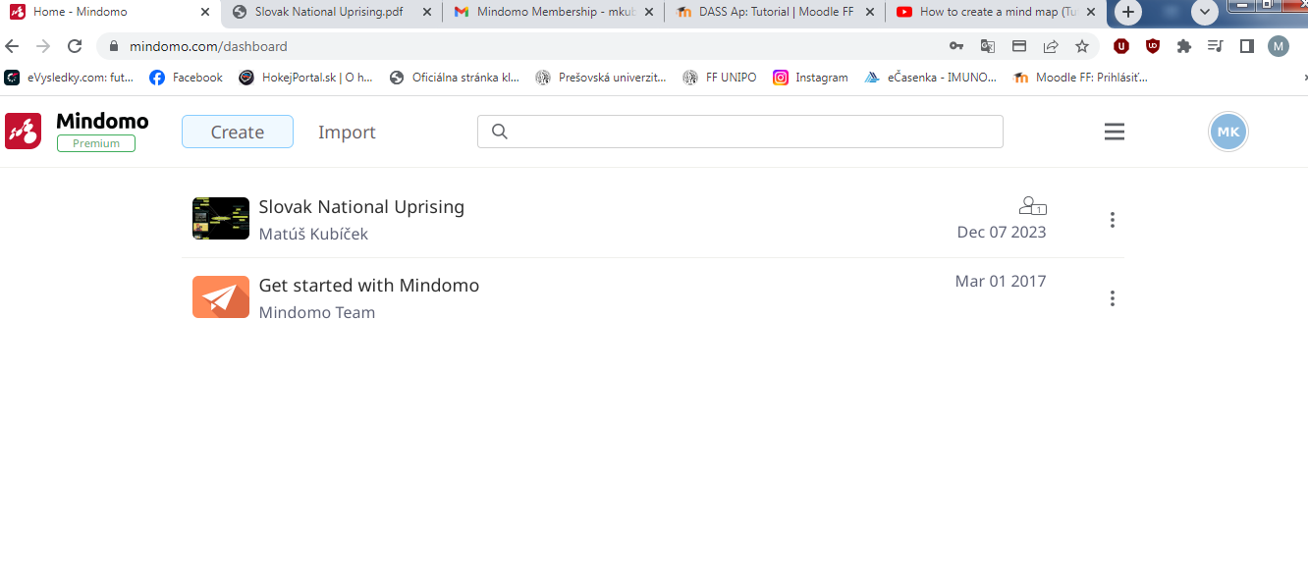
When you will click near your Diagram, you will see the options,but only if you already made one,as me,if not,then click on get started with the Mindomo under the Diagram:
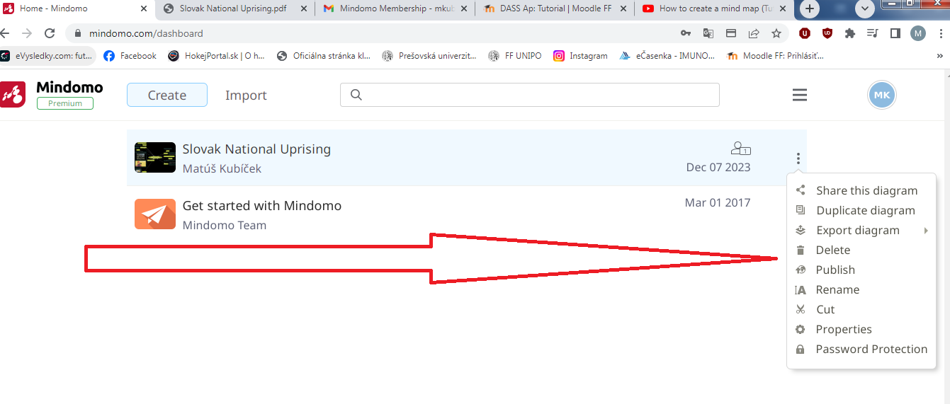
There are also the other 2 options, one,when you click on the three black indents on the right top corner, and when you click on your ID, mine is MK in the blue circle, on the right top corner.
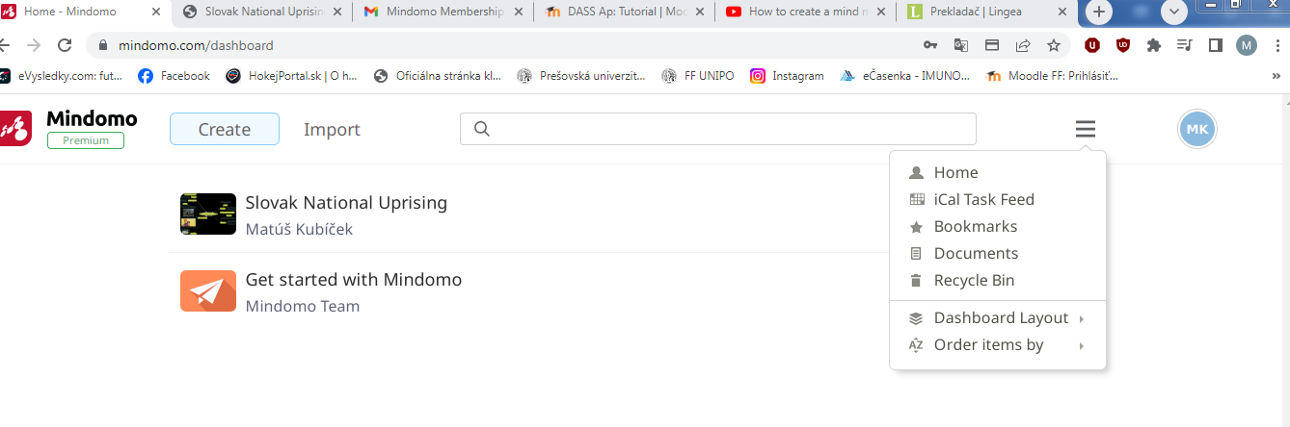
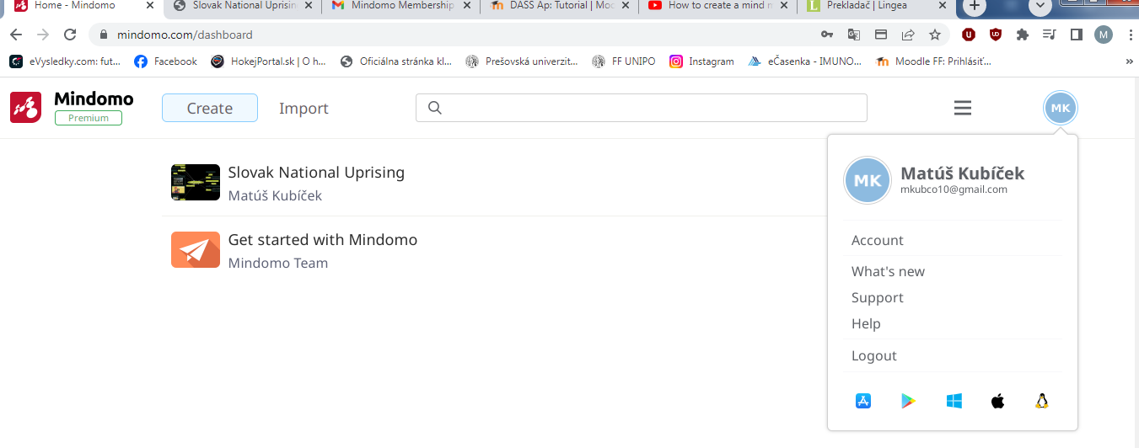
Then, click Get Started with the Mindomo,which will display you the basic features of a tool.
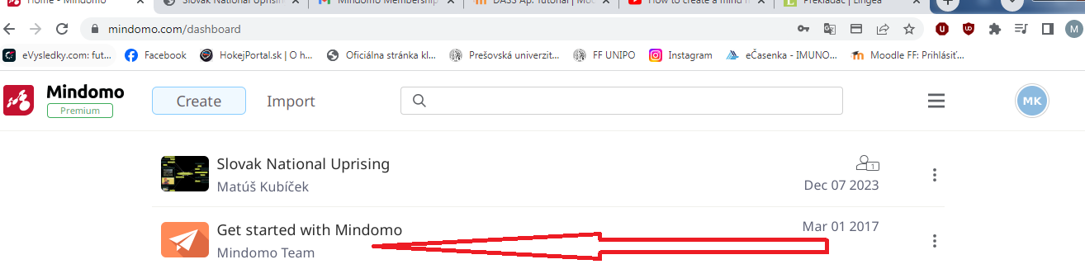
The features are here:
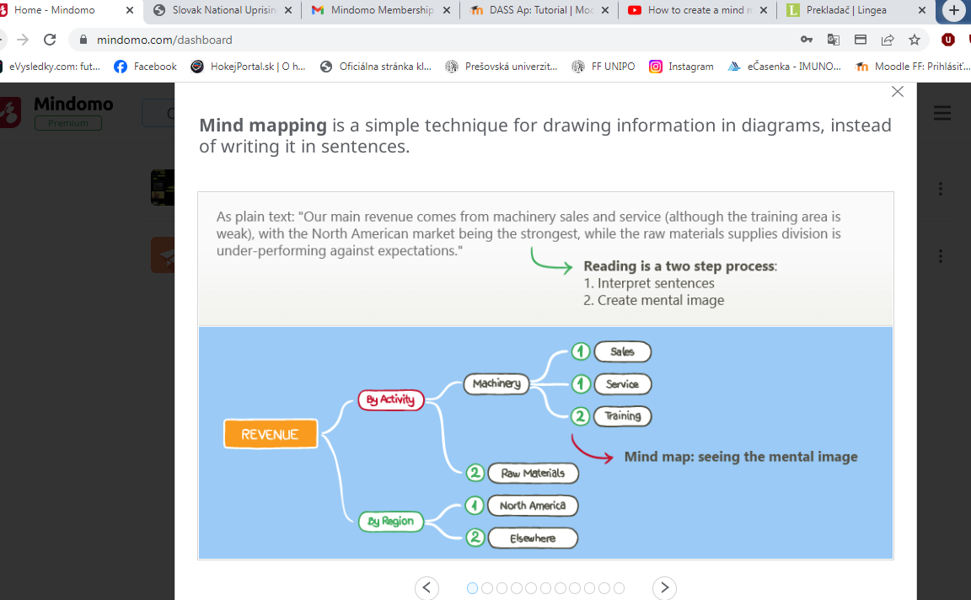
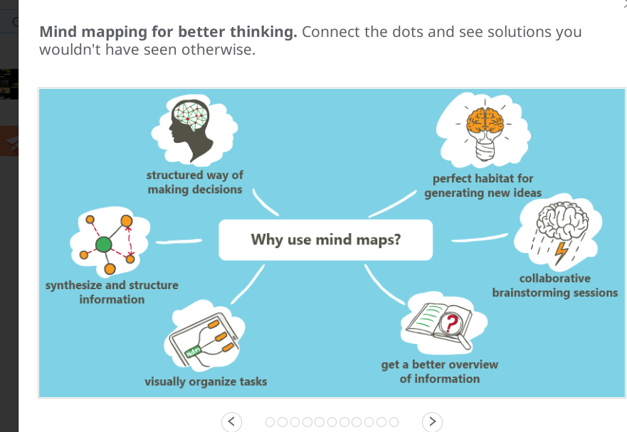
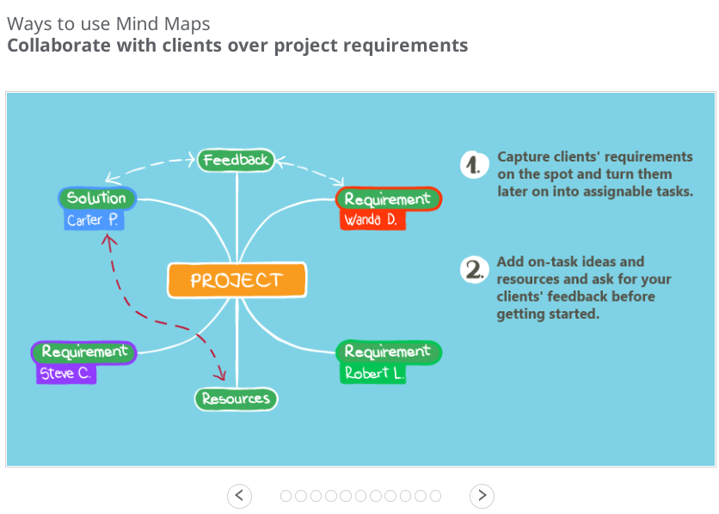
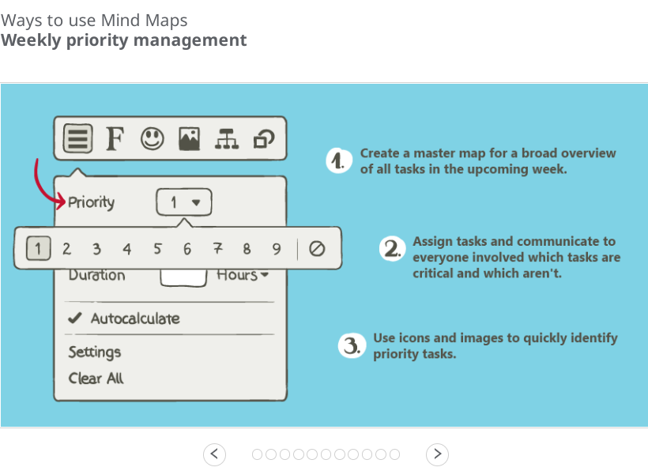
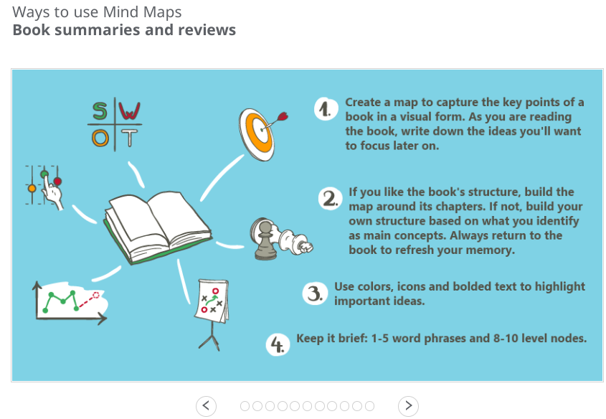
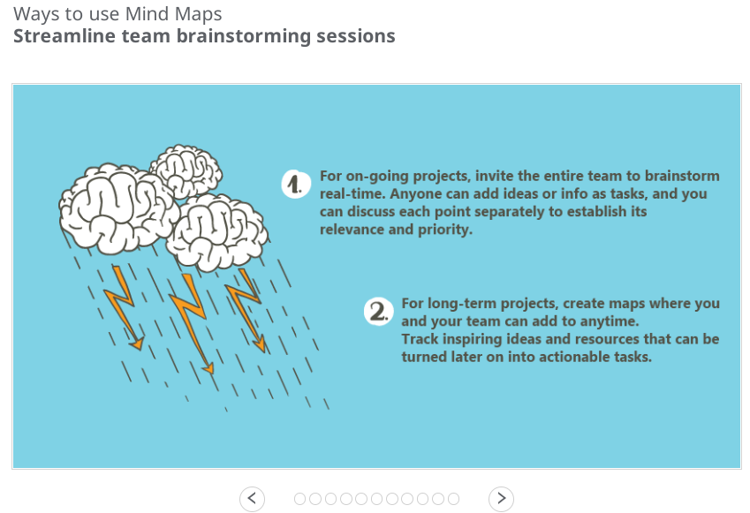
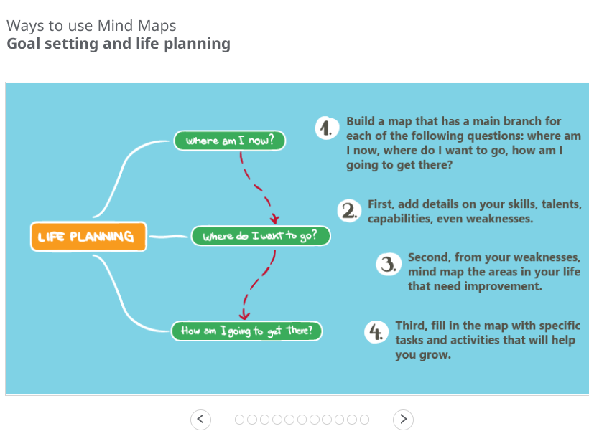
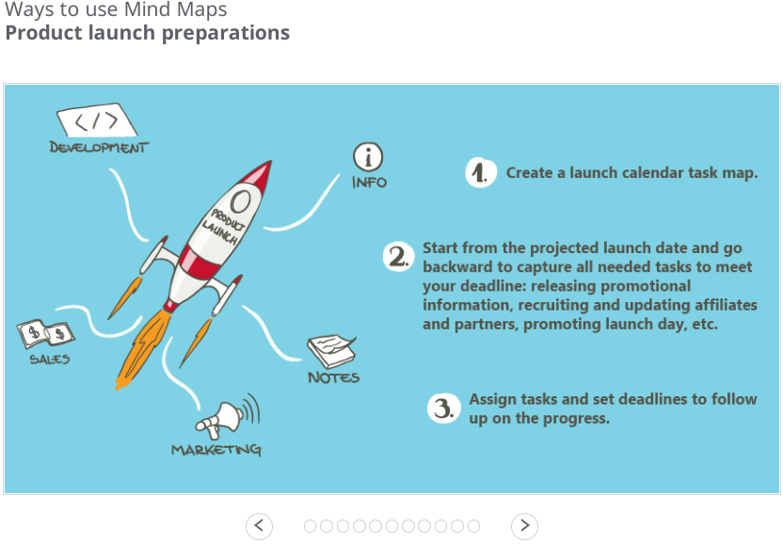
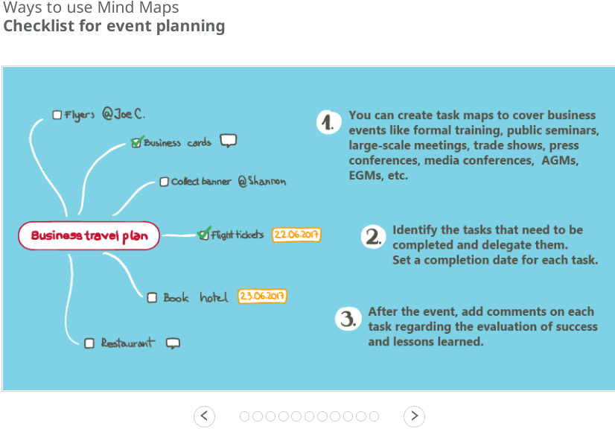
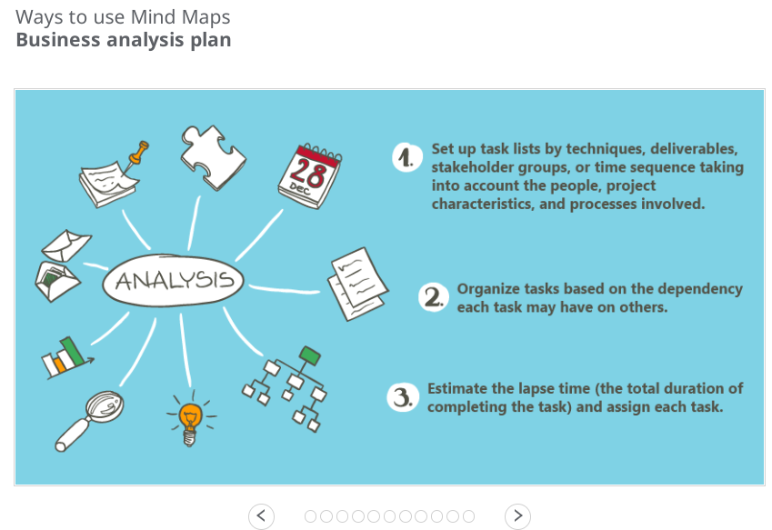

Creating with Mindomo
Now, we will create something using Mindomo. Click on Create on the top left corner.
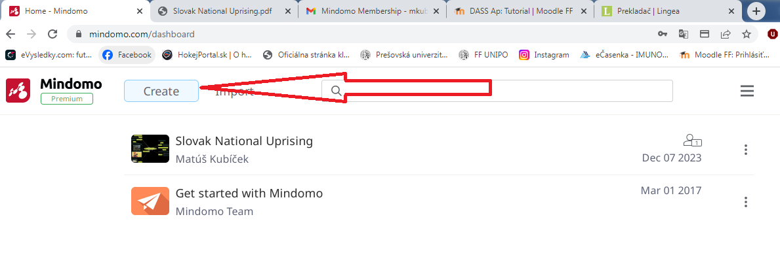
After clicking,there will be many options.
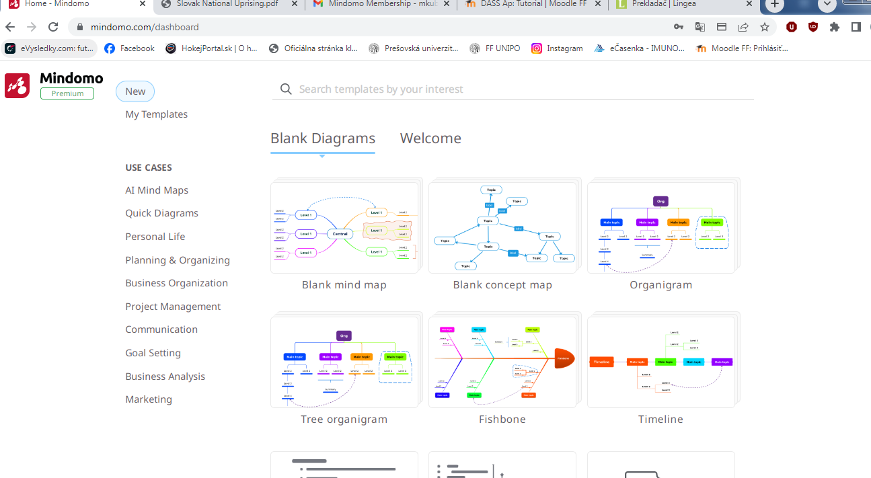
Apart from the option called Blank Diagrams,there will also be one titled Welcome, which is composed of some 21 slides ppt presentation about how to create your own piece. You can download this ppt as pdf an use whenever you want. You can also add your own template when creating a new file.
Okay, now let´s choose for example a template called Blank mind map. Just click on it and choose an option Create which will appear immediately after clicking.
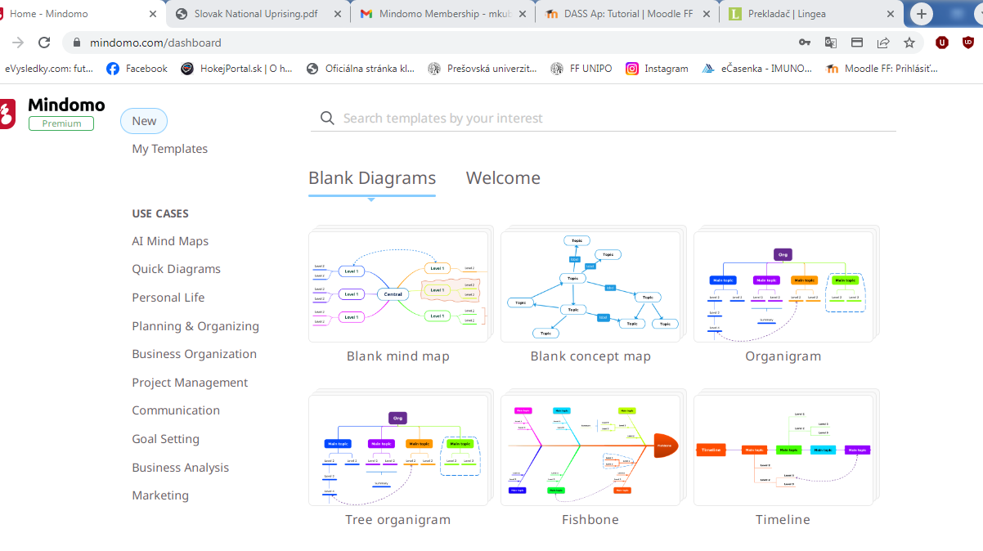
After clicking Create, this screen with a central theme and options on the left side will appear. You can choose from different themes,make a copy,save file and it also displays all your changes which you made throught the process of creating in a timeline(,e.g. delete 22:10 E.T.)
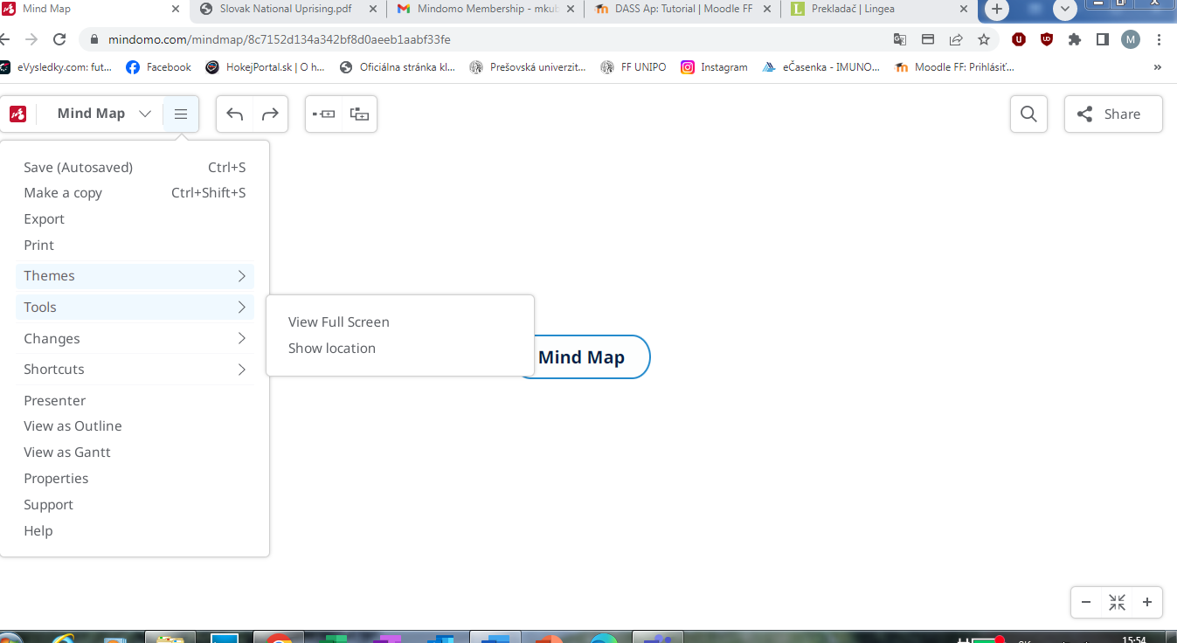

The most interesting feature which appears here is called Shortcuts.There,you can find all the keyboard shorcuts which will help you create your own material. Here are some of them:
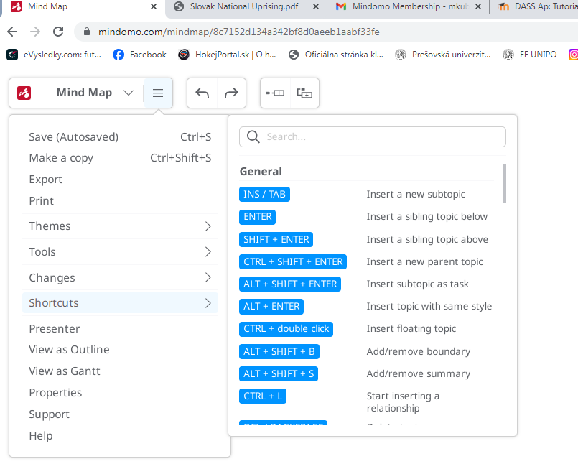
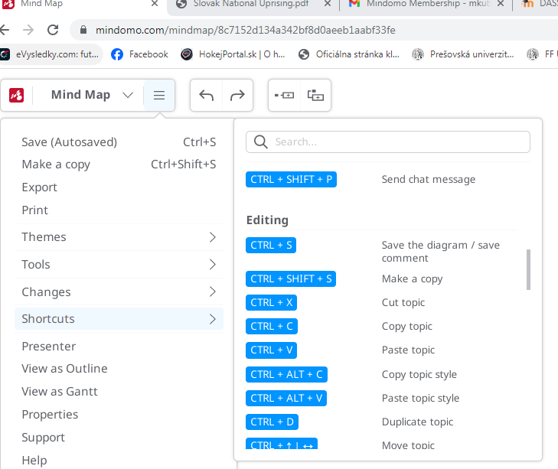
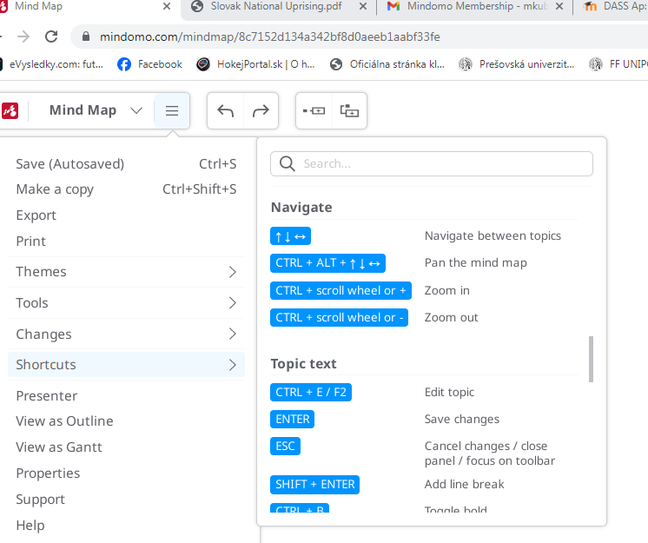
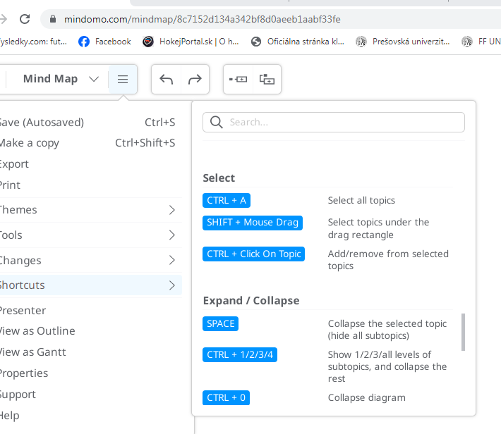
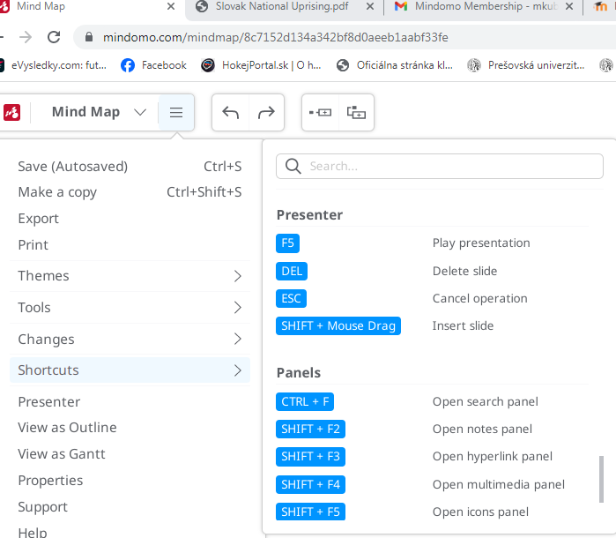

By clicking on the central theme, these options will appear:
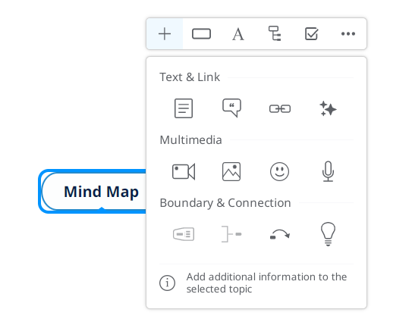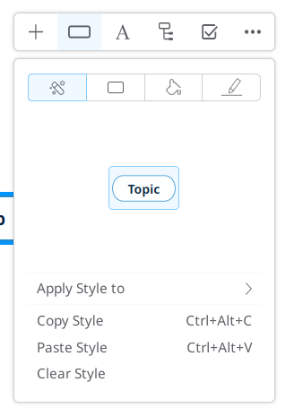
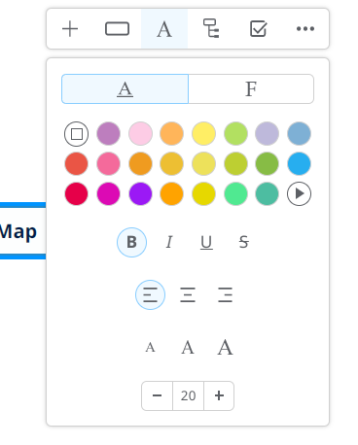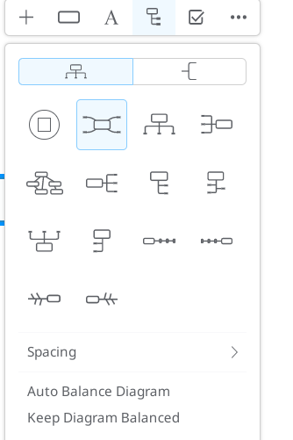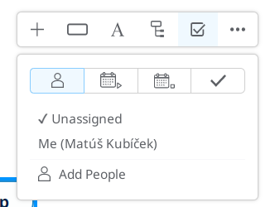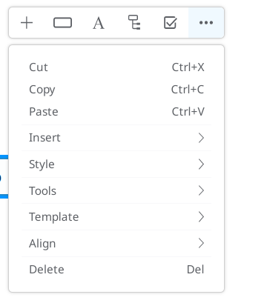
As you can see, you can doo basically what you want with your file.

